Axopar to mark a decade of innovation and adventure disclosing the all-new Axopar 29 range

Cannes, 14 September 2023

As Axopar enters its 10th year in the marine industry in January 2024, the company proudly reflects on its remarkable journey of innovation, growth, and trailblazing achievements. Since its inception, Axopar has redefined boating and created an entire new genre – adventure boating. And today, the company remains at the forefront of development as the original adventure company, leading the way in innovation and design.
As larger players are moving into the adventure genre today, this only further validates that Axopar was on to something truly disruptive, and on the right path already in 2014, when their functional, fuel-efficient and competitively priced Axopar 28 range was first revealed.

“Innovate or die”
“Axopar welcomes this competition as long as it brings more innovation and better products to the market for fellow boaters to enjoy. “Axopar's success is not just about being a responsible leader; it's about inspiring others to explore a new genre of boating. "We are the original, and we will stay committed to being the forerunner in order to innovate and continue paving the path for future boat designs and functionality", says Jan-Erik Viitala, Founding Partner at Axopar Boats.
All these ten years have been well utilized, and you’re soon about to see the results.

The all-new Axopar 29 range
In Cannes Axopar is now thrilled to surprise the market with a glimpse of the all-new Axopar 29 range, built upon its legacy and success of the predecessor, which has to date been delivered to an amount of over 2700 boats.
The Axopar 29 range will embody the company's unwavering determination and resilience (Sisu) to continue pushing boundaries and innovations in design, efficiency, drivability and functionality.
Taking attention to detail to new heights, with years of experience and an unwavering dedication to value for money, fuel efficiency and modularity, Axopar has now elevated its designs to a level of industrial artistry, with the next Axopar 29 range.

Price point, functionality, economy, drivability, looks and fun now also include:
- More design: The Axopar 29 range will showcase a new sharper industrial design that's more striking in all its details big or small and embodies individuality.
- More spacious throughout the entire boat, redefined space utilization and layouts ensures more room for comfort and functional setups, now with a capacity to overnight up to 4 persons.
- More sociable: A new multifunctional fore deck with forward facing seating and an L-shaped sofa that can be extended into a u-shaped sofa and sun bed as an option. New optional aft deck modules adapted for more socialising onboard.
- More economic: New redefined hull design, improved hydrodynamics and building methods offers significant efficiency increases and weight savings. I.e, – even though the 29 is bigger it weighs almost the same and can be run with the same power at same speeds as its predecessor and now combined with increased on-board fuel capacity it allows for a much extended range.
- More power: Introduction of Mercury Verado V10 powered engines.
- More functional: Everyday living, functionality and servicability is further improved with new onboard solutions.
- More options: Customers can now personalize their Axopar 29 even further to suit their preferences with an array of new options.
- More adventurous: a new option called “The Adventure Collection” will be offered and built in on the first 100 Axopar 29’s leaving the factory in 2024.
The upcoming Axopar 29 range comprises three distinct models: the Cross Cabin, Sun Top and Spyder, each designed to cater to different preferences in boating and lifestyles.
"We are thrilled to reveal here only a few of the numerous key features in the new innovative Axopar 29 range. This range represents the culmination of living our adventure, listening closely to our customers, and our relentless push for new ground-breaking products. Our 10th year anniverary will not just be a celebration of our past achievements, but also a testament of our commitment to keep developing new innovative products, expanding the boat club concept and pushing forward the development of the electric fleet," said Jan-Erik Viitala, Founding Partner of Axopar Boats.

A glimpse of what's to come…
The Axopar 29's journey to launch in Düsseldorf is marked by excitement and anticipation. Stay tuned for a 10th year anniversary full of additional surprises that will capture your imagination and give you an even broader offering coming from Axopar.

Technical specifications:
Length: 8,95m / 29ft
Width: 2,98m / 9ft 8in
Draft: 0,80m / 2ft 8in
Classification: B-offshore / C-coastal
Berths: 2+2 persons
Outboard engines: 300-450hp
Fuel capacity: 400 litres / 105 gal

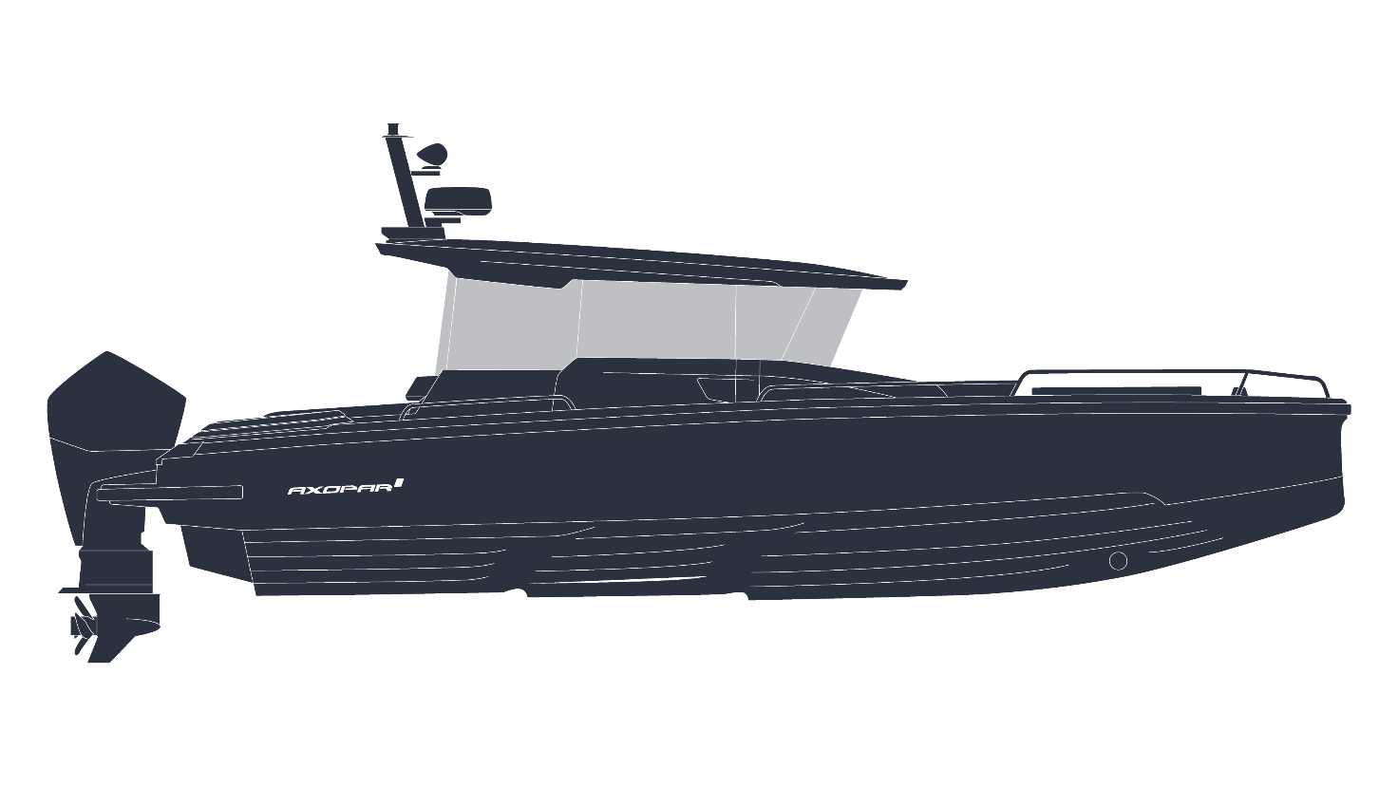
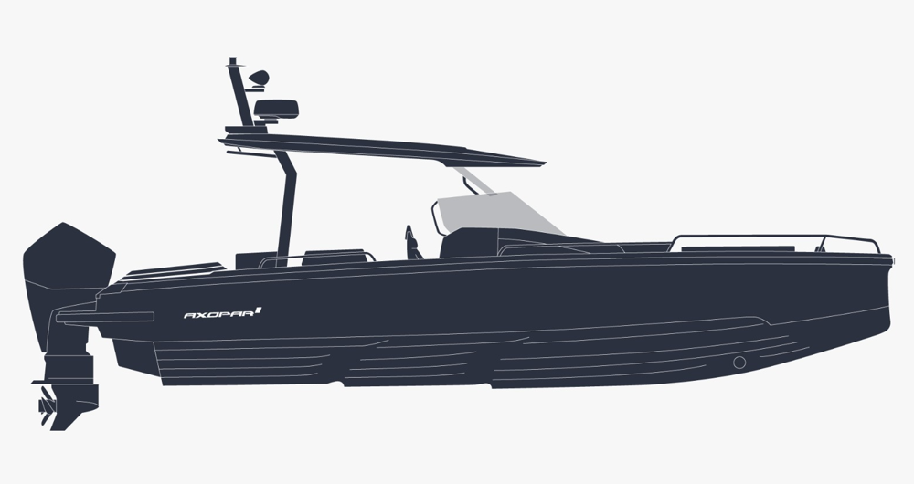

Image caption: The all new Axopar 29 XC (Cross Cabin) and ST (Sun Top)

Pictures can be downloaded via the link HERE.

All Axopar releases are available HERE.

Media contacts for more information on this release:
Ms Marit Holmlund-Sund
Head of Brand & Marketing
Axopar Boats Oy
Mobile: +358 (0)40 538 3519
Email: marit.holmlund-sund@axopar.com

Press Information:
Adam Fiander or Mike Wills
Broad Reach Communications Ltd
adam@broadreachcomms.co.uk /+44 (0)7703 598903
mike@broadreachcomms.co.uk / +44 (0)7884 075439

Axopar in brief:
Axopar, the adventure company, is one of the fastest-growing boat brands in the world. The success derives from the "one boat, one world" concept. It stands for boats that are multi-functional and accessible for the many, anywhere around the world.
As a forerunner committed to continuous innovation, the company listens to its global community of Axoparians and shares the same respect and passion for nature. Axopar's mission is to open new perspectives by bringing people out on the water and creating boats that make waves in the boating industry.
www.axopar.com

