An unparalleled collaboration unites three marine industry pioneers: Axopar, Sail Racing, and Jobe Watersports
Cannes, 13 September, 2023
Introducing The Adventure Collection, where innovation, exploration, and style converge.
Three iconic brands – Axopar, Sail Racing, and Jobe Watersports – have joined forces to introduce The Adventure Collection, a fusion of design, functionality, and passion that has not been seen before on the water.
At the Cannes International Boat Show, Axopar revealed news about their upcoming Adventure Collection. A functional leisure collection of watersports gear and clothing, especially developed for the needs of boaters for time on or off the water.
Axopar, Sail Racing, and Jobe Watersports, leaders in their respective fields, are working closely together sharing their vast experience to develop an even more functional collection, which is seamlessly integrated between these three companies.
The level of detail and cross-over of materials between the clothing, boats, and water sports gear is truly extensive, representing an exercise of successful collaboration.
Jan-Erik Viitala, Founding Partner at Axopar Boats, says, "My dream was to create a unique collaboration where we can offer top-of-the-line products to our global community of Axoparians and all our Axopar fans. This collaboration seamlessly integrates clothing, water sports gear, and our boats. The Adventure Collection is about jointly designing unique products and also achieving a complete material fusion between all three brands. It incorporates a wealth of dedicated details and materials shared between our boats, clothing, and water sports gear, and not forgetting functionality all in order to create an immersive brand experience on the water."
"With a total commitment to the core of adventure, this partnership humbly pushes boundaries to unveil new horizons," emphasizes Linn Fogde, Head of Global Sales of Sail Racing. "The Adventure Collection embodies our shared passion for discovery, innovation and design."
Ivo Rietveld, Product & Design Manager, Jobe Watersports, adds “Partnering with top brands in the market allows us to deliver a watersports experience where every detail is meticulously designed. Our watersports collection is tailor-made to seamlessly fit into the Adventure Collection and complement Axopar boats and Sail Racing clothes, ensuring a coherent transfer of materials and functionality."
Highlighted items from the collection include a purpose built inflatable Axopar kayak for up to two persons, an Axopar SUP, an underwater scooter, waterproof bags that will have dedicated storage locations onboard and also fixable onto the SUP board and kayak to bring them with you securely on your adventures. The Sail Racing clothing will offer a range of high-quality garments like jackets, hoodies, t-shirts, caps and bags with a focus on durability, style and functionality.
In addition this collaboration is truly unique and trailblazing as for the first time ever the integration of gear is transferred extensively onto a range of boats, into the upcoming all new Axopar 29 range boat itself, which will be launched in Düsseldorf 2024.
The new Axopar 29 will perfectly match the design and details of the Adventure collection, where each component complements the other. When ordering the gear together with the Axopar 29 from the factory this gear will be accompanied with an integrated air pump onboard, dedicated storage space for the underwater scooter with charging and dedicated locations for the bags to be stored securely and accessible. In addition the Axopar 29 will feature a transfer of details from the gear, such as comprehensive anti-skid material from the SUP board, with all its details transferred onto the Axopar 29 throughout the entire boat, just to mention a few of the details onboard. The Adventure collection items will be available online or selected as an option package when buying the boat.
This collection represents a dedication to innovation and exploration, embodying the spirit of adventure and freedom that is at the core of Axopar, Sail Racing, and Jobe Watersports. These brands are known for their commitment to bringing more boaters on the water.
The Adventure Collection will be officially launched at the Düsseldorf BOOT24 boat show in January. The attention to detail, technology and detail transfer is so immense that you can only experience onboard to truly understand the depth of the transfer. We welcome you to Düsseldorf to truly get an understanding what this is all about.

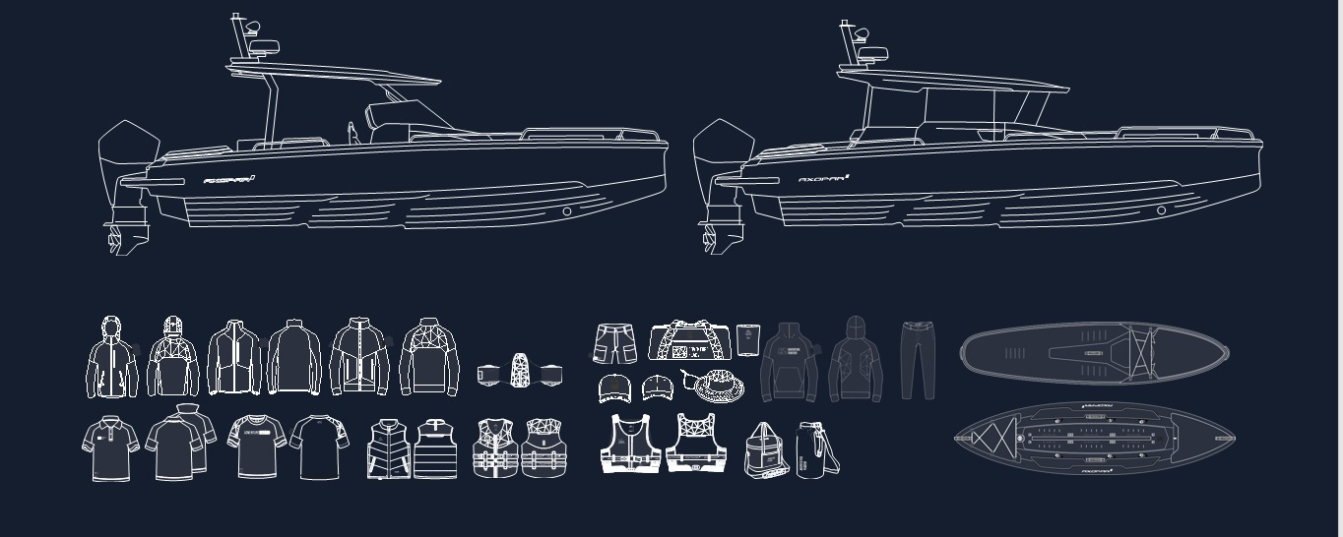
Image caption: The Adventure collection by Axopar, Sail Racing and Jobe Watersports.

More pictures can be downloaded here: https://www.dropbox.com/scl/fo/ohinnvscucpk9hqeef2nx/h?rlkey=n2qm18ftwy0bc6qyua5bijuvl&dl=0

All Axopar releases are available at https://www.dropbox.com/scl/fo/sozjhxqb6kikiyu2t9fnl/h?rlkey=m37h7gkul0yvybqf6qso6lhij&dl=0

About Axopar: Axopar, the adventure company, is one of the fastest-growing boat brands in the world. The success derives from the "one boat, one world" concept. It stands for boats that are multi-functional and accessible for the many, anywhere around the world.As a forerunner committed to continuous innovation, the company listens to its global community of Axoparians and shares the same respect and passion for nature. Axopar's mission is to open new perspectives by bringing people out on the water and creating boats that make waves in the boating industry. www.axopar.com
About Sail Racing: On July 7, 1977, the Sail Racing brand was officially registered and was re-launched in 1999 with the founders’ original passion for sailing still firmly anchored in place.
Today, Sail Racing International AB is a highly specialized company based in Sweden. The company is focused on designing and constructing the most innovative and technical gear for high-speed sailing. The Sail Racing development team consists of apparel designers, industrial designers, and a 3D animator. This talented, tight-knit group is committed to discovering new materials, achieving the best fit, and creating the most appealing designs from input provided by the professional sailing athletes who form the Sail Racing Test Team.
Sail Racing also designs, markets, and sells a sportswear collection. The look of this collection is always created with speed sailing in mind. www.sailracing.com
About Jobe Watersports: Jobe is for everyone. We are a community, a global movement, a family of real people, who are discovering the beauty of watersports. We create unforgettable #jobemoments for everyone since 1974. No matter who you are, no matter your age or size, no matter your background. When you want to get on the water, you will fit in our family. We develop our products with the greatest care and highest quality materials, every day again. This is what “gets you on the water” means to us. Join our family and share in our love for watersports. www.jobesports.com

Media contact for more information on this release:
Ms Marit Holmlund-Sund
Head of Brand & Marketing
Axopar Boats Oy
Mobile: +358 (0)40 538 3519
Email: marit.holmlund-sund@axopar.com

Press Information:
Adam Fiander or Mike Wills
Broad Reach Communications Ltd
adam@broadreachcomms.co.uk /+44 (0)7703 598903
mike@broadreachcomms.co.uk / +44 (0)7884 075439

