Axopar Celebrates a decade of Innovation and Adventure, and launches the All-New Axopar 29 Range
Düsseldorf, 20 January 2024 - Axopar proudly presents the world premiere of the all-new Axopar 29 Cross Cabin and Sun-Top at boot Düsseldorf 2024. This launch not only marks a new era in innovation but also kicks off Axopar's 10th-anniversary celebrations with the introduction of the Axopar 29 range, looking forward to continue revolutionizing its genre in the boating industry.

A Legacy Honored
The iconic Axopar 28 when launched in 2014 was the first Nordic walkaround outboard-powered 28-foot boat range, laying the foundation for Axopar's future.
The concept and features of the Axopar 28 range were strongly noticed amongst boaters and the international press, and we were honored to be the first company to be awarded with the “hattrick of awards” winning the European Power Boat of the Year, Motorboat Awards, and Best of Boats consecutively for the innovative Axopar 28 range. The Axopar 28 Cabin also became the first European boat to ever win the US Boating Magazine´s “Boat of the Year” award in 2020.
Today you can spot an Axopar 28 absolutely anywhere around the world, from the most exotic locations to buzzing cities, to the most remote locations in the world. Our boating concept and functionality have been embraced by our customers, building a community of Axoparians globally that has resulted in 28’s being produced and sold in thousands.
We took all the learnings from the Axopar 28 accumulated over a decade and carried them over to a completely new type of boat with the all-new Axopar 29. It is more than a successor, it is a testament to our Finnish determination and perseverance (SISU), to keep pushing for innovation and our promise to continue building even better boats for our customers.
At Axopar we do not change anything without a sense of purpose, but when we see clear opportunities for improvement, we want to act immediately for the benefit of our customers. This might explain how fast and dedicated we have been able to develop our company and its range of boats in only 10 years.
The all-new Axopar 29 range, where more is more
This all-new range represents the culmination of living our adventure and listening closely to our customers. Everything onboard, all you can see, touch and feel, has been improved and enhanced to our customers’ wishes. It has all been done with a sense of purpose, and for specific reasons, in terms of improved functionality, usability, comfort and higher quality with a new visual presence, still without forgetting our origins and paying homage to the predecessor, the Axopar 28´s.
The Axopar 29 range, therefore, is even more multifunctional, maintaining its exceptional value for money, made to push and redefine the adventure boat genre, even when the sub-30-foot category itself has developed enormously with new brands entering the market in the last years.
A new confident design, meets improved functionality
You can see the Axopar 29 is clearly made with the same Axopar DNA; however, looking closer, the new, bolder and more adventurous design language and attitude, combined with a wave of new and innovative ideas and fresh solutions, gradually unfold.
Not only redefined hydrodynamics and improved efficiency, the hull itself is more defined, more fluid, and with a less angular stance about it. The bow section is higher with a more pronounced flair that will impart a sense of protection from the elements and maintaining its renowned ride quality, even in rougher conditions.
The walkaround side-decks are also wider, making maneuvering around the boat easier.
The sliding doors have a complete design makeover and are taller and wider than before, allowing easier access to the inside of the cabin. The Axopar 29 XC now boasts a full-width, panoramic ‘wraparound’ rear screen, which changes the visibility from the cabin completely, letting more light and nature inside.
The Axopar 29 boats will be offered with the new ‘Adventure Collection’ line, with some special and rather unique touches integrated in the boat, including a clothing line designed together with Sail Racing, and a water activity package created together with JOBE, sharing all the same design and functionality.
A completely reimagined layout, with more than a few hidden surprises
New lounge style seating area
The new layout on the foredeck provides so much more volume in the bow and you can now seat comfortably up to 8 people. Such is the sense of space that when you're looking forward from the helm you could almost imagine yourself being on the Axopar 37.
Adding the optional U-sofa extension, together with the front facing bench, both together create a kind of new O-shaped lounging area, which is great for socializing. A hi-lo table can be used for drinks and al fresco eating, and infill cushions offer the option of a huge sunbed.
New Multicabin in the bow
But the biggest surprise in the bow is the large and spacious multi cabin that serves three different usages, whatever the customers choose to their preference. The multi cabin as standard functions as 1. a large under deck storage area for gear and luggage, to which you can extend an 2. optional fresh water toilet and sink.
The multicabin is large enough to transform to 3. an optional full-length sleeping cabin for occasional overnighting.
The multicabin forward gives tons of extra usability for the boat and now you can have two couples, or two adults and two kids staying overnight, when selecting the main sleeping aft cabin to the boat. Or the Axopar 29 now has an overnighting capability for those that do not wish to take away any space from the functional aft deck.
New space sensations in the Axopar 29 XC pilothouse
The pilothouse feels vastly more spacious, and you can move around with less thresholds, greater legroom for front and rear occupants and more headroom.
The optimized layout, improved sightlines, combined with the wraparound panoramic front and rear windscreens offer an enormous difference and a much airier sensation inside, with significantly improved 360-degree visibility all around.
Repositioning the c-pillars to a more forward location has made reversing and mooring manoeuvres in tight and restricted spaces that much safer and easier.
Sliding doors that now open wider, offset helm seating and an interior floor that is now flat, together mean easier and more comfortable freedom of movement.
The 29 Sun Top now with sliding canvas roof
Following the very successful Axopar 37 Sun Top with its sliding canvas roof, this feature has now been transferred over to the Axopar 29 Sun Top, to provide sun protection and still having that open air feeling and letting the sun inside the cockpit when you want. The sliding canvas roof is offered standard with manual operation, and optionally with electric actuator.
New innovative cockpit layout for the Axopar 29 ST
Introducing a new optional innovative seating layout that entirely transforms the sociability onboard the 29 Sun Top. This new U sofa configuration, together with a large, foldable hi-lo table, creates a comfortable seating arrangement around the cockpit. The large aft backrest has four different positions that can easily be changed to truly utilize the seating or lounging to the maximum. The hi-lo table also turns into a large sun bed, and with this you can have a second lounging area onboard accompanying the fore deck lounge area, perfect for a day out at anchor.
New and improved aft-cabin functionality
The practical aft-cabin doubles as a huge ‘multi-storage’ space for transporting gear and equipment, and for easy loading there is now a wide-opening hatch so that all kinds of gear, including wakeboards and water skis etc, can be accessed easily and safely stowed from the aft deck.
Reimagined aft deck utilization
Further optimized space utilization and improved layout throughout the entire boat will ensure more functionality and cruising comfort. The aft fender boxes, for example, are larger, in fact all storage units in the front and aft of the new boat are bigger than previous.
The starboard side fender box can now also be optionally transformed into a convenient top loading fridge, complete with a fresh water faucet and sink and is available no matter what aft deck configuration is selected.
The general extra space that our design team has created throughout the entire boat, by stealing an extra few centimetres everywhere, has made the range more practical than ever before.
Performance, efficiency and handling redefined
We take pride in achieving a unique balance of speed with excellent fuel efficiency, providing an exceptional range for a boat of this size, and the Axopar 29 offers a truly extraordinary driving experience that stands out among other 30-foot boats.
Together with improved hydrodynamics, the bigger 400 liter fuel tank offers a cruising range of 200+ nautical miles, and a wide cruising speed zone between 22 to 32 knots where liters per nautical mile consumption remain almost unchanged. The new hull dynamics also raise the fast-cruising speed of the Axopar 29´s up towards 37 knots, still maintaining good fuel efficiency and driving comfort.
Functional, cozy and sociable, the Axopar 29 feels like a sports car, but is also very stable and safe to drive with a proven hull more than capable of handling the rough stuff when needed.
Quiet and creak-free, due to a better integration of components
The 29 range has further developed integration of structured components and mold parts into the hull, which increases stiffness and minimizes the reliance of using additional parts and fixings.
The idea is to use the boat’s own inherent strength and integrity to support parts of the structure and this efficient production principle not only saves excess weight and cost but streamlines the entire manufacturing process and reduces the boats potential for noise and vibration, creating a more silent-running, creak and rattle-free environment for passengers to enjoy.

Key Technical features of the AX29 range
- Completely redesigned hull and hydrodynamics.
  - drivability and handling developed to a new standard in sub 30-foot boats
  - new improved driving experience, feeling more like a small Axopar 37 to drive
  - most economic cruising speed range optimized for 22kts to 32 kts @ flat 1.8l/nm
  - increased fast cruising speed, up to 37 knots @ 2.0l/nm
  - increased range, +200nm with fuel tank capacity now increased to 400l.
  - fuel economy improved with up to 30% increased hull efficiency
  - more stable and improved seaworthiness to take you anywhere in the world
- New manufacturing techniques and methods
  - stiffer and more rigid construction and revised manufacturing methods
  - reduced weight on all components leading for reduced environmental impact
  - PET recycled materials in the hull replacing any organic materials in the hull
  - increased quality in production, improved component longevity for stronger resale value
  - streamlined production, higher quality thru repeated procedures and reducing overall cost and waste, offering more to our customers with reduced price impact, keeping the range leading the competitive pack
- Smart Design and space utilization
  - advancing design aspect on aesthetics and looks, instantly recognizable
  - incorporating innovative design concepts and additional features for added functionality
  - optimized interior layout, creative use of space
  - more spacious bow layout, for added on board comfort and socializing
  - maximizing functionality in limited spaces, more storage and easier functioning solutions
  - improved wheelhouse layout, a more comfortable and enjoyable user experience
  - greater use of glass areas for better all-round visibility and light

Technical specifications of the AX29 range
Length overall, incl. bathing platforms: 9,40m / 29ft
Beam Width: 2,98m / 9ft 8in
Draft to props: 0,9m / 2ft 8in, shallow draft for beaching 0,60m / 2ft
Construction: GRP
Hull design: Twin stepped 22,6 degree V "Sharp entry hull"
Max speed (approx.): 48 kts
Fuel consumption : cruise - 1,8l / nm (2x200hp @ 26 kts)
Fuel consumption: cruise - 1,6 l / nm (1 x 350hp most economic cruising
speed range 24-34 kts)
Fuel capacity: 400 litres / 105 gal
Weight w. average options (excl. engine): 2800 kg (6173 lbs)
Outboard engines: 300-400hp (1 x 300-400 or 2 x 200 hp)
Persons on board: 6 in cat B / 9 in cat C
Berths: 2+2* persons
Classification: B-offshore / C-coastal
Pricing
Axopar 29 XC Cross Cabin: 60,200 excl. VAT (guide price, final pricing to be still confirmed)
Axopar 29 Sun Top: 57,800 excl. VAT (guide price, final pricing to be still confirmed)

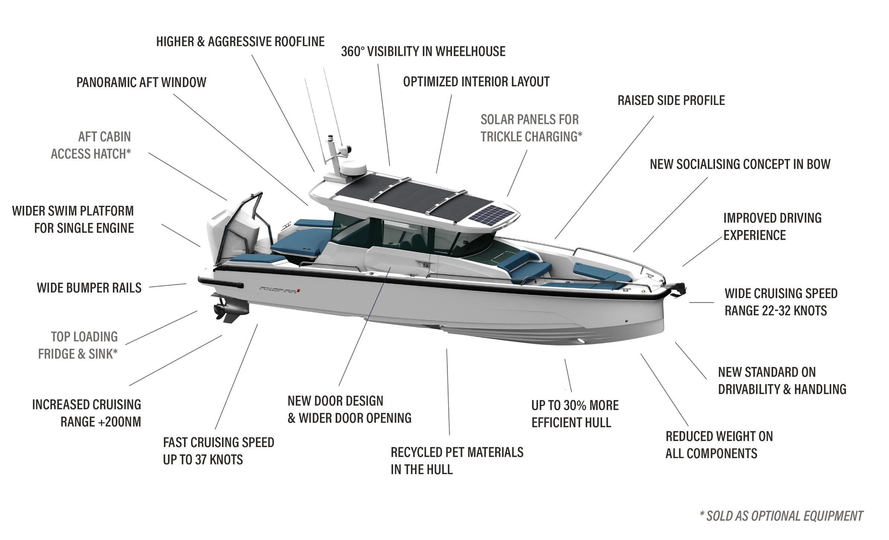
Axopar 29 XC Cross Cabin: Highlights

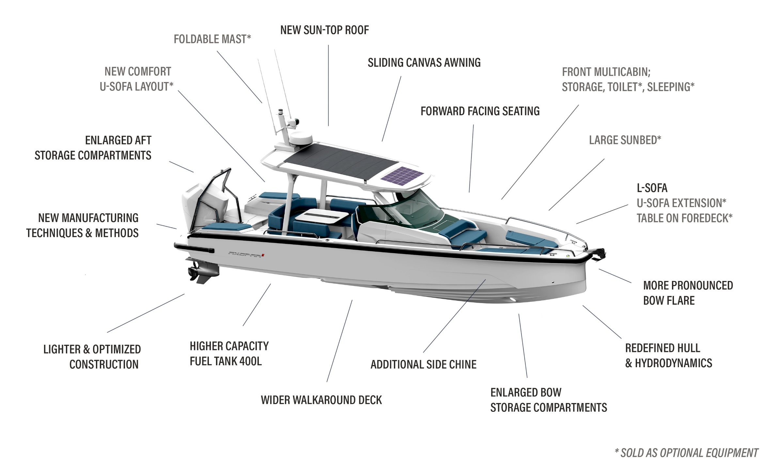
Axopar 29 Sun Top: Highlights

Launch of Axopar 29 in a Spectacular Anniversary Year
2024 marks a milestone in Axopar’s history, as we reach our 10th anniversary when the company proudly reflects on its remarkable journey of achievements and growth.
Axopar created a new genre – adventure boating – and today the company remains at the forefront of development as the original benchmark, leading the way in innovation and design.
Axopar Founding Partner, Jan-Erik Viitala, says:
“I could not have imagined the scale and how far Axopar has developed in only 10 years when we founded the company in 2014. To become the industry leader in a genre created all of its own - adventure boating - is a unique achievement in itself. We’re proud of our worldwide community of Axoparians and we are super excited about the next 10 years ahead of us. The crucial cornerstone in our success has been our customers and professional partners who believed in our concept and embraced it from day one. For them we are beyond grateful, and without our customers we would not be where we are today. We are excited to see the Axopar 29´s hitting the market, and this 10-year anniversary will be celebrated throughout the whole year with more news and a lot of cool things coming from Axopar in 2024.”

Visit us in Hall, B-59 at boot Düsseldorf from the 20th to 28th January 2024. The all new Axopar 29 XC Cross Cabin and Sun Top version will have their World Premiere at boot Düsseldorf 2024.

Media Contacts for More Information on This Release:
Press Information:
Adam Fiander or Mike Wills
Broad Reach Communications Ltd
adam@broadreachcomms.co.uk / +44 (0)7703 598903
mike@broadreachcomms.co.uk / +44 (0)7884 075439
Ms. Johana Tidström
Interim Head of Brand & Marketing
Axopar Boats Oy
Mobile: +358 (0)45 351 3333
Email: johanna.tidstrom@axopar.com
All Axopar releases are available at https://www.axopar.com/pressroom

